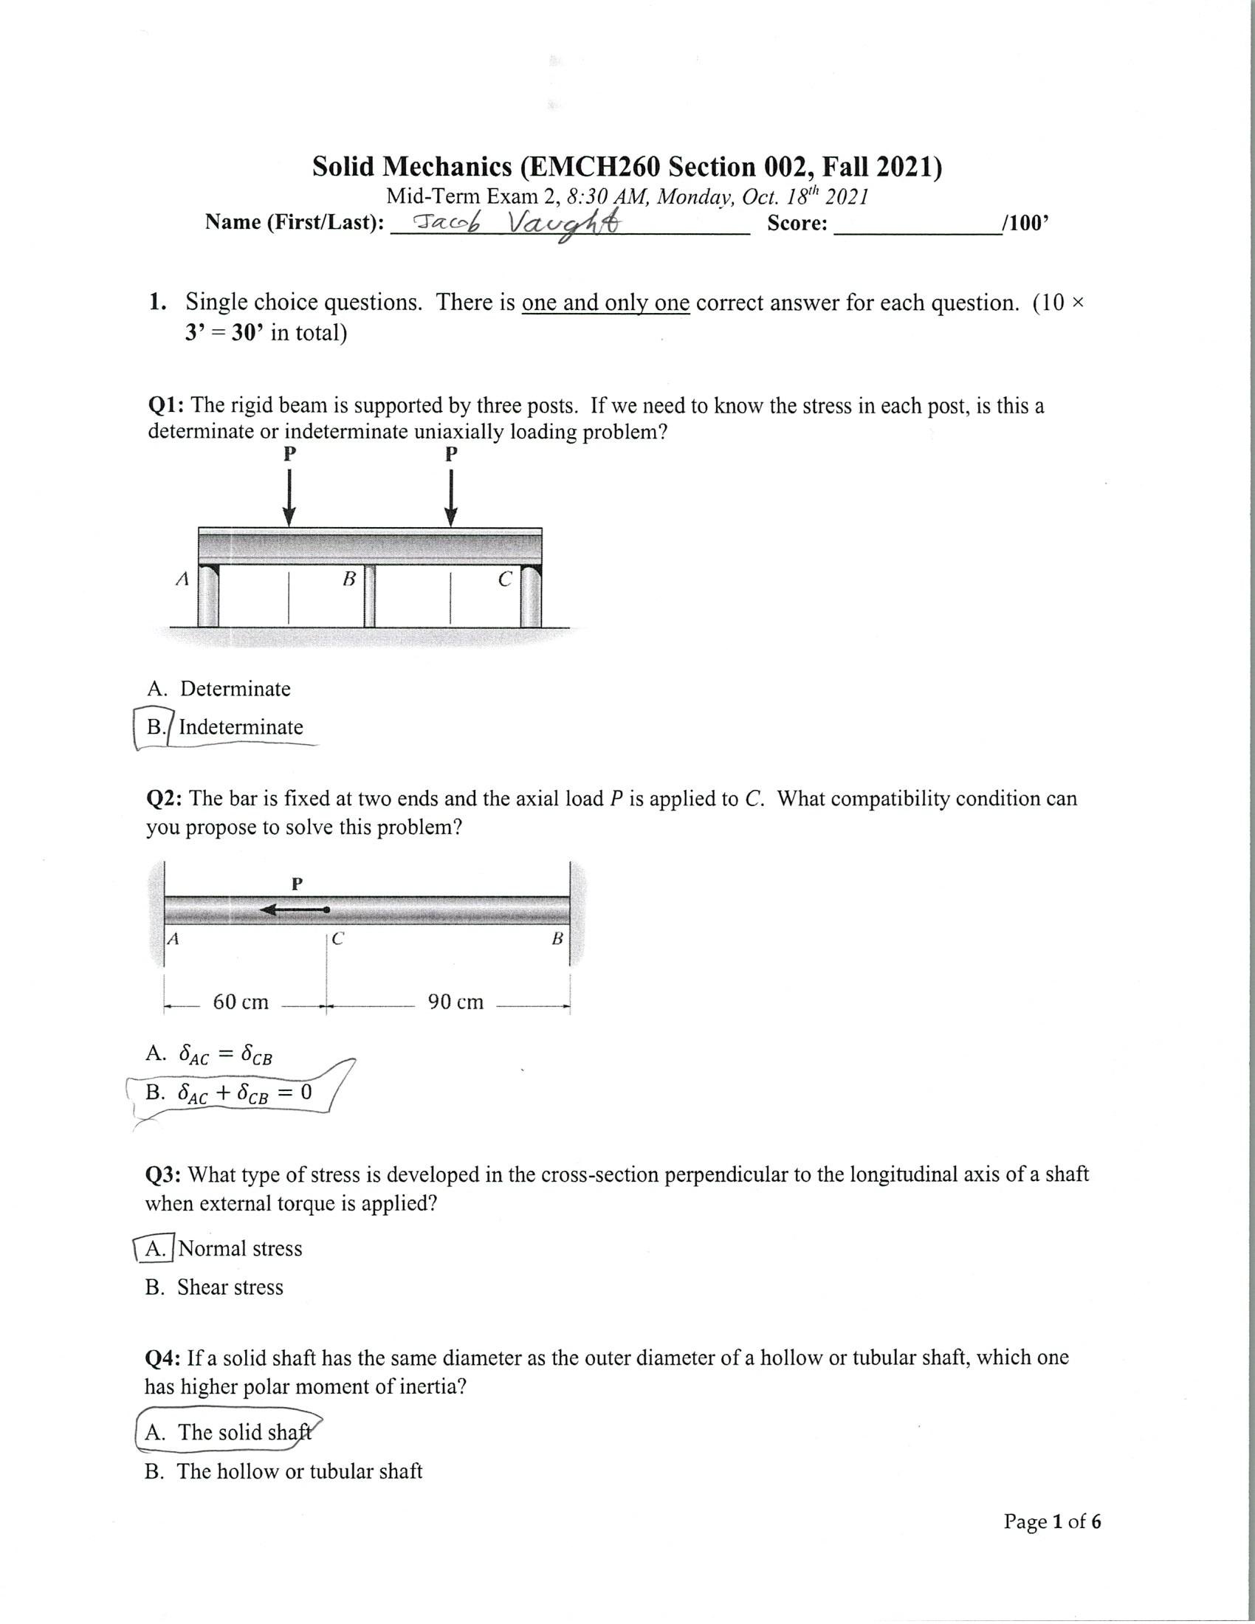

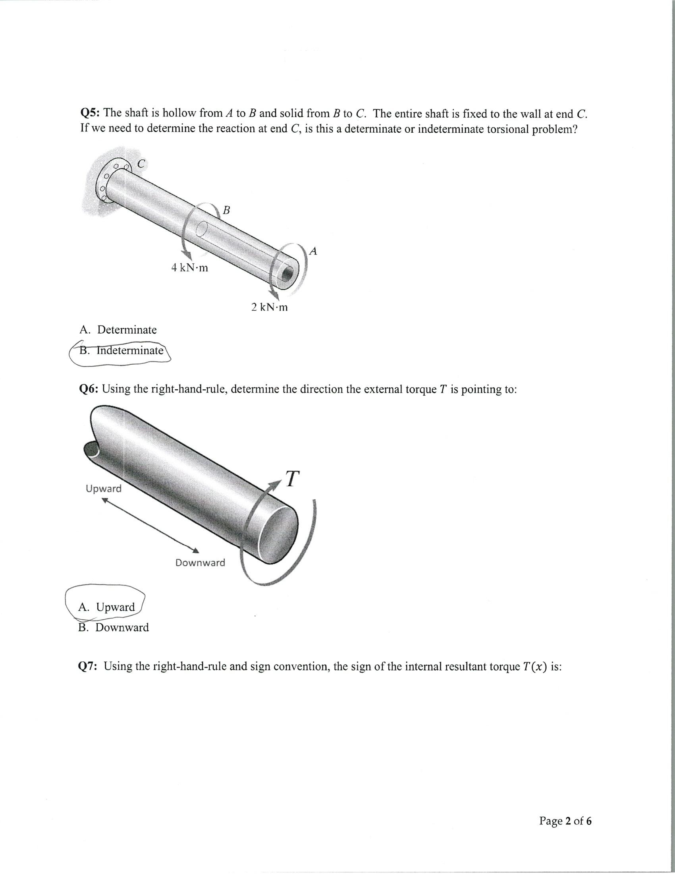

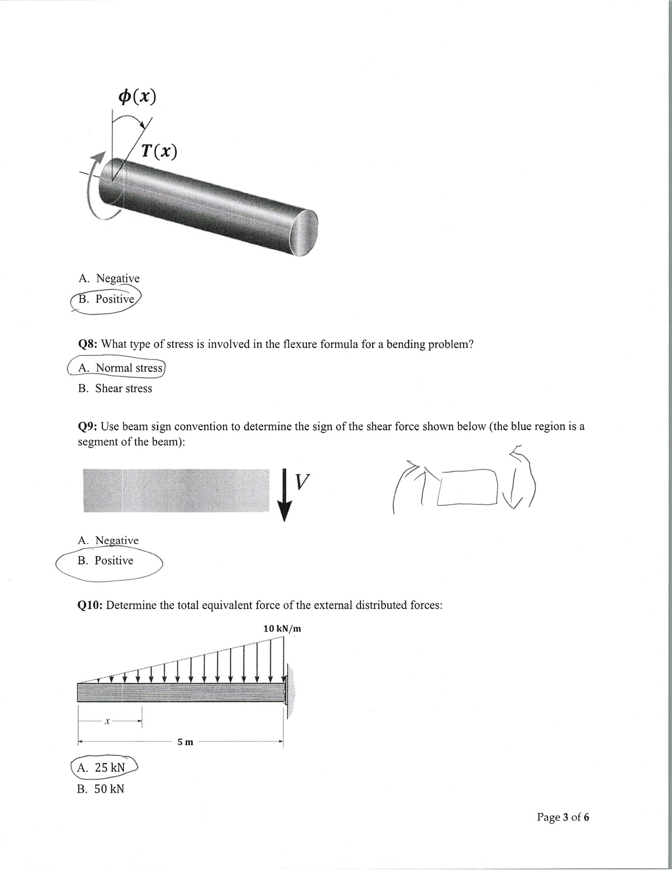
PROBLEM #2
BUILDING MAIN EQUATIONS:
$$Inertia or J=\frac{π}{2}{\left(r\right)}^{4} or if hollow:J=\frac{π}{2}({R outer}^{4}-{R inner}^{4})$$
$$Shear stress or τ=\frac{T*r}{J}; Angle= ϕ=\frac{TL}{JG}$$
$$ϕmg=ϕst$$
$$T=Tst+Tmg$$
$$Jst=\frac{π}{2}*{0.02}^{4}$$
$$Jmg=\frac{π}{2}*({0.04}^{4}-{0.02}^{4})$$
SOLVING SAID EQUATIONS
$$\frac{Tmg}{\frac{π}{2}*{0.02}^{4}*20*{10}^{9}}=\frac{Tst}{\frac{π}{2}*\left({0.04}^{4}-{0.02}^{4}\right)*80*{10}^{9}}→Tst=60\frac{Tmg4}{15}Tmg$$
$$60Tmg+Tmg=T→Tmg=\frac{15}{19}T$$
$$\frac{1}{60}*Tst+Tst=T→Tst=\frac{4}{19}T$$
MAX TORQUE FOR EACH MATERIAL
$$T=\frac{τ*J}{r}$$
$$Tst MAX=\frac{75*{10}^{6}*\frac{π}{2}*\left({0.04}^{4}-{0.02}^{4}\right)}{0.04}=2250*π$$
$$Tmg MAX=\frac{45*{10}^{6}*\frac{π}{2}*{0.02}^{4}}{0.02}=180*π$$
$$T based on Steel Tmax→2250*π=\frac{60}{61}T→T=\frac{4575}{2}π≅7186.4N∙m$$
$$T based on Magnesium Tmax→180π=\frac{1}{61}T→10980π≅34494.7N∙m$$
$$Steel Tmax<Magnesium, thus 7186.4 N∙m is the Maximum torque.$$

$$Angle= ϕ=\frac{TstL}{JstGst}=\frac{2250*π*0.9}{\frac{π}{2}*{0.02}^{4}*80*{10}^{9}}=\frac{81}{265}≅0.316 radians or18.13 degrees.$$

